Storyboards 02

Sound FX: Menu confirmation

Music: None

Camera: Fixed

Props:

Characters:

Transition: First scene when game loads, continues to main menu.

Sound FX:

Music: Menu music

Camera:

Props:

Characters:

Transition:

Sound FX:

Music: Menu music

Camera:

Props:

Characters:

Transition:

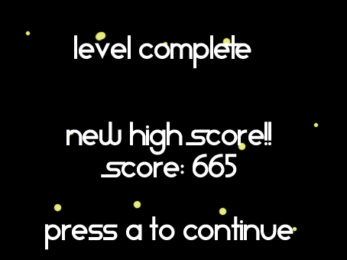

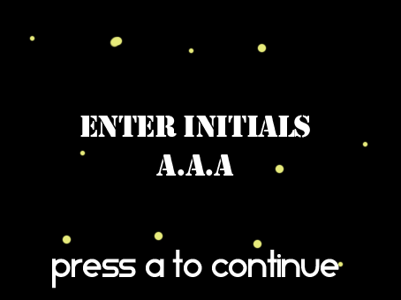

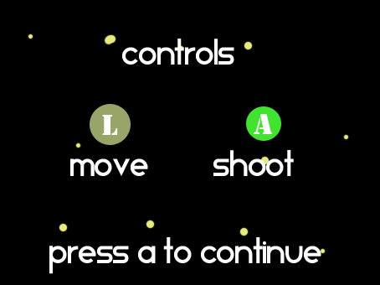

# Storyboards 01

Sound FX: Menu Selection, Menu item change

Music: Menu music

Camera:

Props:

Characters:

Transition:

Sound FX:

Music: Stage music

Camera:

Props:

Characters:

Transition:

Sound FX:

Music: Stage music

Camera:

Props:

Characters:

Transition:

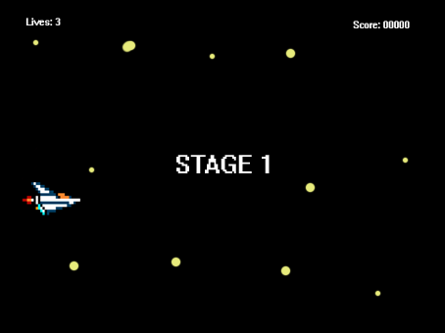

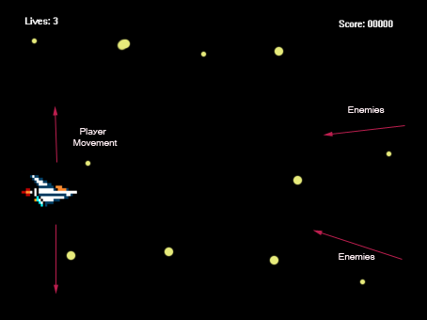

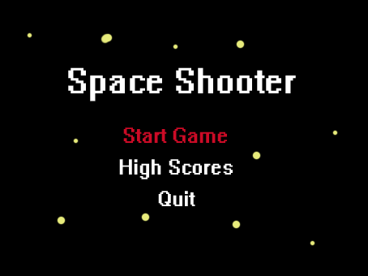

# Storyboards 01

Sound FX:

Music: Menu music

Camera:

Props:

Characters:

Transition:

Sound FX:

Music:

Camera:

Props:

Characters:

Transition:

Sound FX: Laser fire

Music: Stage music

Camera:

Props:

Characters:

Transition:

